**Online Journal System**

*A Project Submitted in Partial Fulfillment of the Requirements for the*

*Degree of*

Bachelor of Science in Computer Science and Engineering

*by*

**Deep Bhowmik**

CSE 05506822

&

**Joyonto Kumar Roy**

CSE 05406745

Supervised by: TarikuzzamanEmon

Assistant Professors and Coordinator Senior Lecturer

|  |
| --- |
| C:\Users\Adnan\Desktop\1.jpg |

Department of Computer Science and Engineering

STAMFORD UNIVERSITY BANGLADESH

February 2019

**Abstract**

The goal of this journal system is to increase the visibility to the participating journals, use and impact of the university's research publications by offering them to use through the university's own online journal system. The journal system consists of full text materials produced in the Dhaka University, covering the full range of academic journals of the University. An efficient and dynamic online journal system which university students can read and download a journal and if they want they can upload their own journal in this website. Abstracts of journal papers are sometimes students or user written, often lack important information, and occasionally convey a biased picture. The primary target of this journal paper is the main types of university department categories information. If somebody need to post a journal before they need to register and then go.

**Approval**

The project report “Online Journal System” submitted by Deep Bhowmik ID: CSE 05506822,Joyonto Kumar ID: CSE 054 06745, to the Department of Computer Science & Engineering, has been accepted as satisfactory for the partial fulfillment of the requirements for the degree of Bachelor of Science (B.Sc.) in Computer Science & Engineering and as to its style and contents.

Board of Examiner’s Name, Signature and Date:

|  |  |  |
| --- | --- | --- |
| **……………………………...** | **……………………………..** | **……………………………..** |
|  |  |  |
| **(Board Member 1)** | **(Board Member 2)** | **(Board Member 3)** |
| Date: | Date: | Date: |

Supervisor’s Signature and Date:

**……………………………...**

**Supervisor Name**

Date:

**Declaration**

We, hereby, declare that the work presented in this Project is the outcome of the investigation performed by us under the supervision of Tarikuzzaman Emon, Assistant Professors and Coordinator, Department of Computer Science \& Engineering, Stamford University Bangladesh. We also declare that no part of this Project and thereof has been or is being submitted elsewhere for the award of any degree or Diploma.

Signature and Date:

**……………………………...**

**Student Name:**

Date:

**……………………………...**

**Student Name:**

Date:

Dedicated Our beloved parents and Our honorable Supervisor sir Tarikuzzaman Emon.

**Acknowledgements**

At first we would like to thank the almighty ALLAH for giving me ability, chance and such cooperating supervisor. With Her mercy, today we are completing our thesis work successfully.

We would like to take the opportunity to express my gratitude to Tarikuzzaman Emon sir our respected supervisor. Although she was always loaded with several other activities, he gave more than enough time in this work. He not only gave me time but also proper guidance and valuable advice whenever we faced with some difficulties. Her comments and guidance helped me in preparing our project report.

We would like to thank all my respected teachers, who inspired me in every step. We also thankful to my friends who helped me in a number of ways by providing various resources and moral support.

Last but not least we are grateful to our family; who are, always with us in our every step of life.

List of Figures 1

List of Tables 2

1: Introduction 4

1.1 Problem Defination …………………………………………...4

1.2 Motivation 5

1.3 Chapter Summary 5

2: Background Study 7

2.1 Existing related system……………………………………………………………….7

2.2Literature Review…………………………………………………………………….8

2.2.1 PHP………………………………………...……………………………………8

2.2.2 HTML……………………………………...……………………..………….…16

2.2.3 CSS………………………………………...……………………………...……17

2.2.4 Jquery…………………………………...……………………..….……………17

2.2.5 MySQL………………………………………...………………………………18

2.3 Chapter Summary………………………………………………………………….18

3: System Requirement 19

3.1 Software & Hardware*……………………………………………………………..………....*20

3.1.1 Software Requirements………………………………………………………………………………………..20

3.1.2Hardware Requirements………………………………………………………………………………………..20

3.2 Software setup process………………………………………………………………20

3.3 Chapter Summary………………………………………………………………….31

4: Project Details 32

4.1 Database Details 33

4.2 System Design 37

4.2.1 Timeline Chart………………………………………………………...……….37

4.2.2 System Flowchart……………………………………………………...……….38

4.2.3E-R Diagram…………………………………...……………………...……….39

4.2.4Use Case Diagram…………………………………………………...…..…….40

4.2.5Activity Diagram……………………………………………………...……….42

4.2.6 Sequence Diagram……………………………………..……………...……….45

4.2.7Collaboration Diagram………………………………………………...……….46

4.3Input Project Design 49

4.4 Chapter Summary 56

5: Conclusion& Future Work 57

5.1 Future wrok 58

References 59

# List of Figures

Figure 3.0.2: Xampp Server Setup Process………………………………………….……….23

Figure 3.0.3: Xampp Control Panel………………………………………………………….27

Figure 3.0.4: CodeIgniter Download…………………………………………………………28

Figure 3.0.1:CodeIgniter Folder……………………………………………………………..29

Figure 4.0.2: Timeline Chart…………………………………………………………………37

Figure 4.0.3: System FlowChart…………………………………………………………......38

Figure 4.0.4:E-R Diagram……………………………………………………………………39

Figure 4.0.5:Use Case Diagram Admin…………………………………………………......40

Figure 4.0.5:Use Case Diagram Home Owner…………………………………………........41

Figure 4.0.6:Use Case Diagram Home Seeker…………………………………………........41

Figure 4.0.6:Activity Diagram Admin……………………………………………………….42

Figure 4.0.8:Activity Diagram Supplier……………………………………………………..43

Figure 4.0.9:Activity Diagram Home Seeker………………………………………………..44

Figure 4.0.7: Sequence Diagram Admin……………………………………………………..45

Figure 4.0.8: Sequence Diagram Supplier……………………………………………………45

Figure 4.0.12: Sequence Diagram Buyer…………………………………………………….46

Figure 4.0.9:Collaboration Diagram Admin…………………………………………………47

Figure 4.0.14:Collaboration Diagram Home Owner…………………………………………48

Figure 4.0.15:Collaboration Diagram Home Seeker…………………………………………48

Figure 4.0.10: User Interface Home………………………………………………….………49

Figure 4.0.11: User Interface Properties……………………………………………………..49

Figure 4.0.12: User Interface Contact………………………………………………………..50

Figure 4.0.13:Contact Form………………………………………………………………….50

Figure 4.0.14:Register New Account………………………………………………………...51

Figure 4.0.15:User Interface Login…………………………………………………………..52

Figure 4.0.16: User Interface Submit Property………………………………………………52

Figure 4.0.17: Admin Panel Login…………………………………………………………...54

Figure 4.0.18: Admin Panel Dashboard……………………………………………………...54

Figure 4.0.19: Admin Panel Property Table…………………………………………………55

Figure 4.0.20: Admin Panel Category Table…………………………………...……………55

Figure 4.0.21: Admin Panel User Table……………………………………………………..56

# List of Tables

Table 4.0.1: Users Table…………………………………………………………………....33

Table 4.0.2: Contact_info Table…………………………………………………………….34

Table 4.0.3:Property Table………………………………………………………………….35

Table 4.0.4:Category Table……………………………………………………………...…36

Table 4.0.5: Booking Table…………………………………………………………………36

# 

# Chapter 1

# Introduction

# 1 Introduction

We live in modern times. The most surprising contribution of this modern era is the internet. Since the Internet is invented, the world is moving fast. Modernity is going on in different parts of the world. As the Internet is moving the world, so has the human life much easier. The Internet is not backward in education. The role of the Internet in modern education is immense. Now almost all students are dependent on this internet, because all the books, journal and guides are available in this internet .So buying books or journal has decreased. It is a matter of thinking that we create online journal website. The website was originally designed for students. Many times, there is no place for the students to post journal of the university's website. There are many students who write a lot of good journals, mainly for them, this website. This website allows them to upload their own research and read the journal.

## Problem Definitions

Roam around to rent a house has always been a hassle for people. Especially, on recent times, people have so many priorities based on which they have to rent their house. Some people want their house to be in the commercial space, or some want in a chaos free space. Some people prefer to choose the area of their house relating the religion they belong. Again there are a lot of people who love pets; therefore they want a house which has pet allowance. Basically, in this era of modernism people want to rent their house like online shopping. To rent a house in physical world has become less popular now a days . No one wants to roam around here and there to search for a house. People would prefer a virtual system to rent a house.

To decode this situation and to represent a hassle free environment to the people, a dynamic system can be implemented. That system would give the tenants the best service for renting houses without any kind of hassle. Government can make one unique system where people can rent house based on their priority instead of having so many rental systems. In that system, all the vacant houses of any district of Bangladesh will be listed there. One system will hold every details of every vacant house from any district, any are. To, make the system more liable, there should be a system by which tenants can verify the owner or agent. Also to analysis the place they will rent for house they need to know the location of that. Hence, every information details which have minimum priority to rent a house will hold by the system. There a one special feature for the bachelors so that they can rent houses efficiently as now a day house owners do not want to rent their houses to the bachelors for safety issue.

* 1. ***Motivation***

According to the universal declaration of human rights by which we get to know that is belong to a human the right to have a proper standard ofliving. A standard living place is every citizen’s basic right. .Choosing that place is also their right. As technology is growing so fast every single day, it is necessary to make the system the most dynamic approach. By the need of this, a dynamic home rental system is needed where every citizen can choose their house according to their choice and also it has to be most dynamic as people will access this system at anytime from anywhere.

To make the system more dynamic we have implemented MySQL in the following way. In MySQL, first a priority can be set. Then user will give constraints, based upon the constraints and a priority domain will be created using the available data. The domain is mainly all the rentals related to the constraint set on the priority filed. Hence, users can give any constraints and also set any priority; suppose in our system user can set the priority by area and rent range, then he/she will give their constraints.

As a result, it is such a system which will represent a dynamic approach of renting home.

## Chapter Summary

In this chapter illustrates an introductory section of the system. Here we tried to introduce the users to our system. We tried to share the motivations and the objectives of the sytem with the users. In the upcoming chapters I will discuss about Literature Review of the Project, Project Outline, Requirement Analysis, Planning The Development Process, Project Requirement and Features and Workflow.

# Chapter 2

# Background Study

# 2 Background Study

In this chapter, we decide to review some of already existing system. I am a student of Stamford University. There are many universities inside the camp. Our campus is the most beautiful inside of Dhaka. All universities have their own websites, so our university has websites. But it is sad to say that there is no place for students to post a journal to our website. The use of the internet in education is moving fast. Students are more than studying online from the book. Like it Students can post their writing online through their research. And for this reason, there is a special place. Which is not in our university website. There are many students who want to upload their own research paper online but they can’t. With this thought, we decided to create a journal website for our university. Where student can post, read and download any journal.

**2.1 Existing related system**

Housing has a central importance to quality of life with considerable economic, social, cultural and personal significance.The focus of this project is basically managing housing for low income, medium and high incomes households. Millions of people are living in Dhaka, Housing is a major problem in this city.

1. In 1980, the first property management system was launched in the market. Property management system for hotel management, also known as PMS, is used only for hotel booking.web: <https://www.webrezpro.com/>
2. The VRBO is restal system in booking system of US.

web: <https://www.vrbo.com>

1. Sabbaticalhomes is rental system in booking system of New York web:<https://www.sabbaticalhomes.com>
2. Rent.com is rental system in booking system of Western countries. web:<https://www.rent.com/>
3. iproperty is rental management system in Malaysia

web: https://www.iproperty.com.

When we started our work, there was no system in Bangladesh. But recently launched a website in Bangladesh.web: <https://www.iproperty.com>.

In this existing system there are no email notification services. And its only for fixed property to rent or sell.

* 1. ***Literature Review***

2.2.1 PHP:PHP is a general-purpose scripting language that is especially suited to server-side web development, in which case PHP generally runs on a web server. Any PHP code in a requested file is executed by the PHP runtime, usually to create dynamicweb page content or dynamic images used on websites or elsewhere.

The major points of HTML are given below:

* PHP stands for Hypertext Preprocessor.
* PHP is an interpreted language, i.e. there is no need for compilation.
* PHP is a server side scripting language.
* PHP is faster than other scripting language e.g. asp and jsp.

PHP example.

<!DOCTYPE**>**

**<html>**

**<body>**

**<?php**

echo "**<h2>**Hello by PHP**</h2>**";

**?>**

**</body>**

**</html>**

***2.2.2***HTML: HTML stands for Hyper Text Markup Language, which is the most widely used language on Web to develop web pages. HTML was created by Berners-Lee in late 1991 but "HTML 2.0" was the first standard HTML specification which was published in 1995. HTML 4.01 was a major version of HTML and it was published in late 1999. Though HTML 4.01 version is widely used but currently we are having HTML-5 version which is an extension to HTML 4.01, and this version was published in 2012.

The major points of HTML are given below:

* HTML stands for Hyper Text Markup Language.
* HTML is used to create web pages.
* HTML is widely used language on the web.
* We can create static website by HTML only.

HTML Example

<!DOCTYPE**>**

**<html>**

**<body>**

**<h1>**Write Your First Heading**</h1>**

**<p>**Write Your First Paragraph.**</p>**

**</body>**

**</html>**

2.2.3 CSS: CSS is used to control the style of a web document in a simple and easy way.The major points of CSS are given below:

* CSS stands for Cascading Style Sheet.
* CSS is used to design HTML tags.
* CSS is a widely used language on the web.
* HTML, CSS and JavaScript are used for web designing. It helps the web designers to apply style on HTML tags.

Example

<!DOCTYPE**>**

**<html>**

**<head>**

**<style>**

h1{

color:white;

background-color:red;

padding:5px;

}

p{

color:blue;

}

**</style>**

**</head>**

**<body>**

**<h1>**Write Your First CSS Example**</h1>**

**<p>**This is Paragraph.**</p>**

**</body>**

**</html>**

2.2.4 jQuery: jQuery is a fast and concise JavaScript library created by John Resig in 2006. jQuery simplifies HTML document traversing, event handling, animating, and Ajax interactions for Rapid Web Development.

* jQuery is a small and lightweight JavaScript library.
* jQuery is cross-platform.
* jQuery means "write less do more".
* jQuery simplifies AJAX call and DOM manipulation.

<!DOCTYPE html>

<html>

<head>

 <title>First jQuery Example</title>

<script type="text/javascript" src="http://ajax.googleapis.com/ajax/libs/jquery/2.1.3/jquery.min.js">

 </script>

 <script type="text/javascript" language="javascript">

 $(document).ready(function() {

 $("p").css("background-color", "pink");

 });

 </script>

 </head>

<body>

<p>This is first paragraph.</p>

<p>This is second paragraph.</p>

<p>This is third paragraph.</p>

</body>

</html>

2.2.5 MySQL: MySQL is the most popular Open Source Relational SQL Database Management System. MySQL is one of the best RDBMS being used for developing various web-based software applications. MySQL is developed, marketed and supported by MySQL AB, which is a Swedish company.

## Chapter Summary

In this chapter, we discuss the Code of the whole project what we have been use in our project. We use PHP,HTML,Jquery,CSS,MySQL.

# 

# Chapter 3

# System Requirement

# 3 System Requirement

This chapter aims to document the systems requirements and software setup process. There are two types of requirements Software Requirements and Hardware Requirements.

* 1. ***Software & Hardware***

The most common set of requirements defined by any [operating system](https://en.wikipedia.org/wiki/Operating_system) or [software application](https://en.wikipedia.org/wiki/Software_application) is the physical computer resources, also known as [hardware](https://en.wikipedia.org/wiki/Computer_hardware), A hardware requirements list is often accompanied by a [hardware compatibility list](https://en.wikipedia.org/wiki/Hardware_compatibility_list) (HCL), especially in case of operating systems. An HCL lists tested, compatible, and sometimes incompatible hardware devices for a particular operating system or application. The following sub-sections discuss the various aspects of hardware requirements.

[Software requirements](https://en.wikipedia.org/wiki/Software_requirements) deal with defining software resource requirements and prerequisites that need to be installed on a computer to provide optimal functioning of an application. These requirements or prerequisites are generally not included in the software installation package and need to be installed separately before the software is installed.

* + 1. **Software Requirements:**

1. XAMPP :Web Application Server

2. NetBeens : Integrated Tools

3. MySQL : Database

4. OS: 64-bit Windows 7

* + 1. **Hardware Requirements:**

1. Pentium 4 or AMD or Celeron Processor or above

2. RAM 512 MB or above

* 1. ***Software setup process***

**Installation** (or **setup**) of a [computer program](https://en.wikipedia.org/wiki/Computer_program) (including [device drivers](https://en.wikipedia.org/wiki/Device_driver) and [plugins](https://en.wikipedia.org/wiki/Plug-in_(computing))), is the act of making the program ready for [execution](https://en.wikipedia.org/wiki/Execution_(computing)). Because the process varies for each program and each computer, programs (including [operating systems](https://en.wikipedia.org/wiki/Operating_system)) often come with an *installer*, a specialized program responsible for doing whatever is needed for their installation. Installation may be part of a larger [software deployment](https://en.wikipedia.org/wiki/Software_deployment) process.

* + 1. **XAMPP server setup:**

1. **Open the XAMPP website.** Go to  <https://www.apachefriends.org/index.html> in computer's web browser.

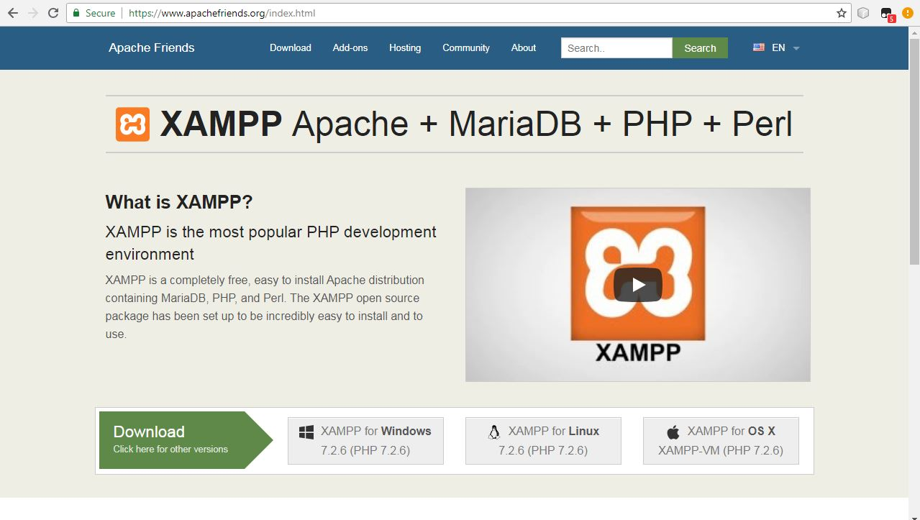

Figure 3.1: Xampp Server Download

1. **Click XAMPP for Windows.** It's a grey button near the bottom of the page.

Depending on your browser, you may first have to select a save location or verify the download.

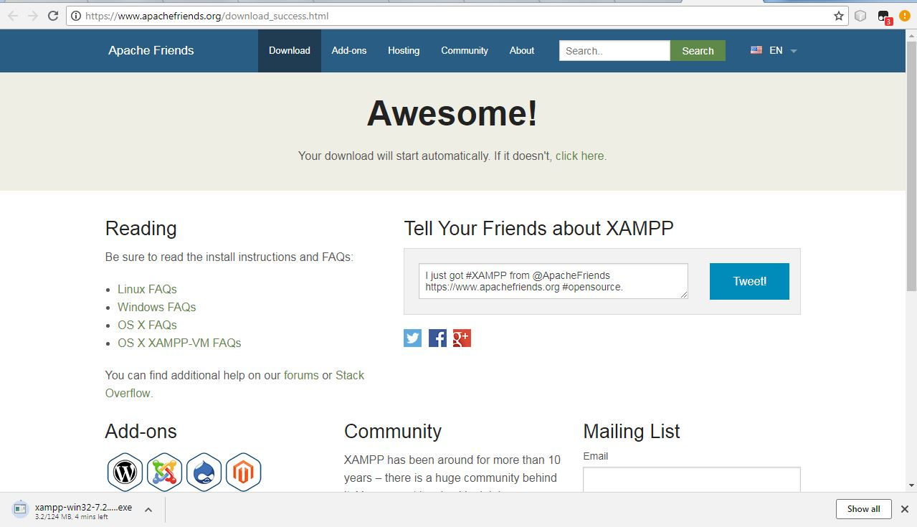

Figure 3.2: Xampp Server Downloading

1. **Double-click the downloaded file.** This file should be named something like **xampp-win32-7.2.4-0-VC15-installer**, and you'll find it in the default downloads location (e.g., the "Downloads" folder or the desktop).

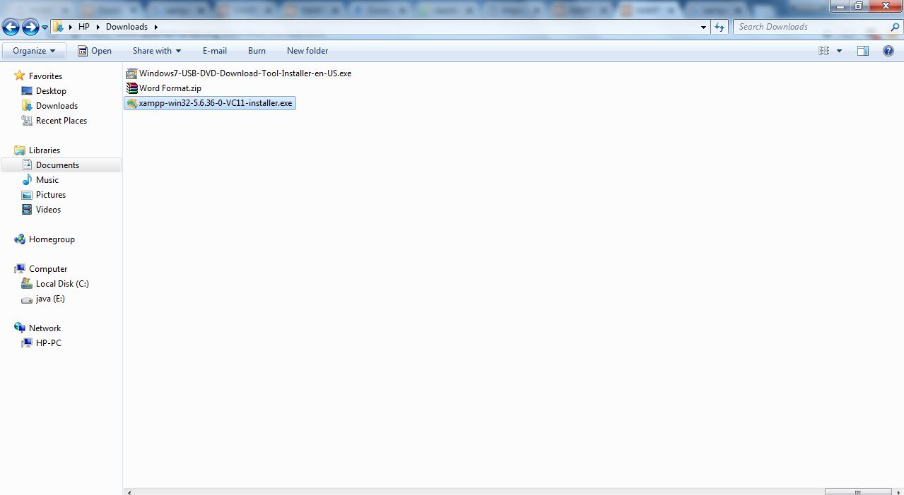

Figure 3.3: Xampp Server Downloading File

**4. Click Yes when prompted**This will open the XAMPP setup window. You may have to click **OK** on a warning if you have User Account Control (UAC)activated on your computer.

**5. Click Next.** It's at the bottom of the setup window.

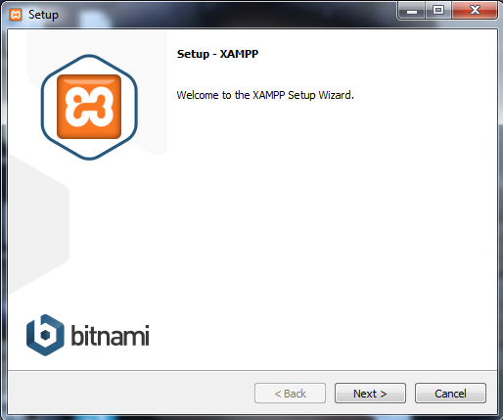

Figure 3.4:Xampp Server Setup Process

**6. Select aspects of XAMPP to install.** Review the list of XAMPP attributes on the left side of the window; if you see an attribute that you don't want to install as part of XAMPP, uncheck its box.

* By default, all attributes are included in your XAMPP installation.

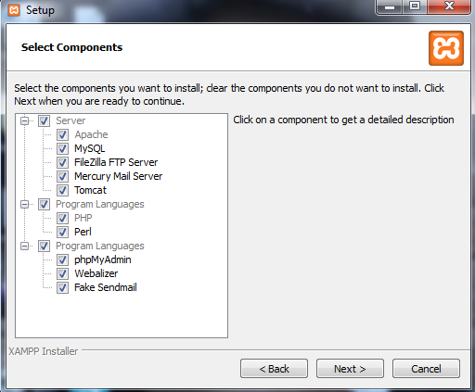

Figure 3.5:Xampp Server Setup Process

**7. Select an installation location.** Click the folder-shaped icon to the right of the current installation destination, then click a folder on your computer.

If you have the UAC activated on your computer, avoid installing XAMPP in your hard drive's folder (e.g., **OS (C:)**).

You can select a folder (e.g., **Desktop**) and then click **Make New Folder** to create a new folder and select it as the installation destination.

1. **Begin installing XAMPP.** Click **Next** at the bottom of the window to do so. XAMPP will begin installing its files into the folder that you selected.
2. **Click Finish when prompted.** It's at the bottom of the XAMPP window. Doing so will close the window and open the XAMPP Control Panel, which is where you'll access your servers.

**Click Next.** It's at the bottom of the window.

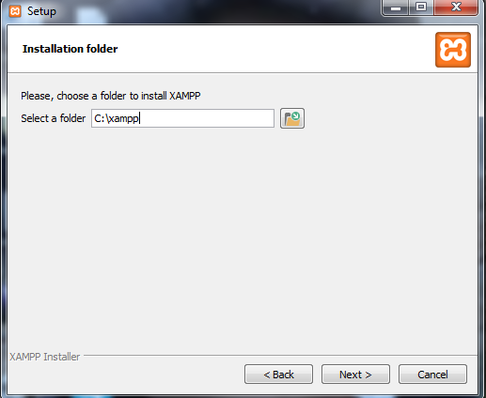

Figure 3.6:Xampp Server Setup Process

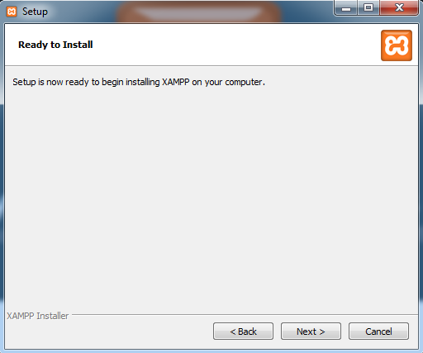

Figure 3.7:Xampp Server Setup Process

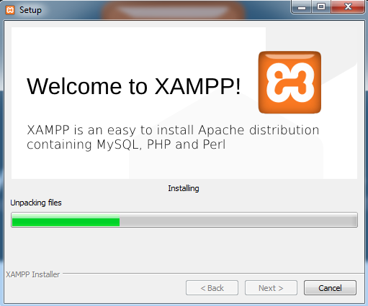

Figure 3.8: Xampp Server Setup Process

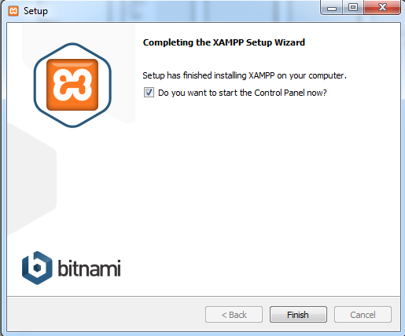

Figure 3.8: Xampp Server Setup Process

**8. Select a language.** Check the box next to the American flag for

English, or check the box next to the German flag for German.

**9. Click Save.** Doing so opens the main Control Panel page.

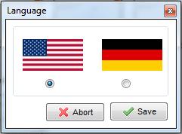

Figure 3.7: Xampp Server Setup Process(select a language)

10.Start XAMPP from its installation point. If you need to open the XAMPP Control Panel in the future, you can do so by opening the folder in which you installed XAMPP, right-clicking the orange-and-white xampp-control icon, clicking Run as administrator, and clicking Yes when prompted.

* When you do this, you'll see red X marks to the left of each server type (e.g., "Apache"). Clicking one of these will prompt you to click Yes if you want to install the server type's software on your computer.
* Counter intuitively, double-clicking the xampp_start icon doesn't start XAMPP.

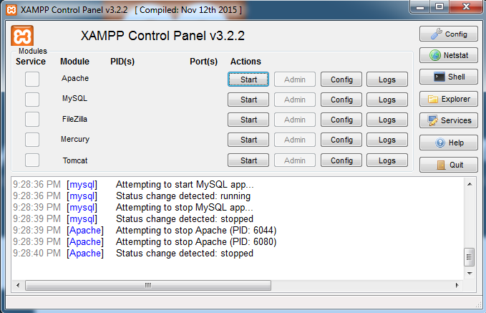

Figure 3.8: Xampp Control Panel